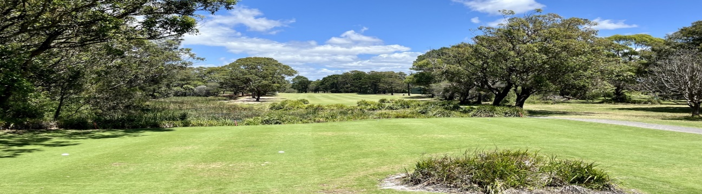
Annual Illowra Tournament 2024
Monday 4th and Tuesday 5th March
Major Sponsors: Building Certification Associates
and Port Kembla Golf Club

MONDAY 4th FOURSOME WINNERS – $85 each and PORT KEMBLA SILVER SALVER TROPHY
TUESDAY 5th STROKE GROSS WINNER – $150 and PORT KEMBLA BOWL TROPHY
SINGLE STABLEFORD WINNER - $70
*Tuesday Events include: Gross Winners, Gross Runner Up, Nett Winners, Nett Runner Up and Ball Comps.
Daily Divisions and Competition Event prizing will be dependent on Competition Entry Numbers.
Event Entry - $25 per player (Tuesday only – Self Serve Salad Plate or Sandwich lunch $8)
Entries Close – February 20th 2024 Please pay - Port Kembla Ladies BSB: 062 766 A/c No: 2801 6435
Reference: Club Name/Surname & Initial (Individual entry). Email entries:ladies@portkemblagolfclub.com.au

Golf Link no. | GA  Hcp | Surname | First name | Please indicate either |  | 4somes  Monday  $25pp  Entry | Single  Tues  $25 Entry | Lunch $8  Salad Plate OR Salad  Sandwich  Self serve |  | Special requests  (eg Tee Time, Travelling with, CART SHARING)
 |  |  |  | Stroke  X | Stablf  X
Totals on each column: |  |  |  |  |  |  |  |  | Total $
CLUB ENTRY FORM_______________________________

FOURSOMES ENTRY DETAILS: Club Name_______________________(Please indicate Teams below)

 | PLAYER NAME | GA | GolflinkNo | PARTNER NAME | GA | Golflink No
1
2
3
4
5

Tee times will be emailed to Club Secretaries or individually where return email address supplied.
Please book Carts through the Port Kembla Golf Shop Phone 4274115

